Computational investigation of the protein binding of BMS-8 and derivatives.

This exercise will provide some computational understanding of the interactions between the BMS-8 ligand and its protein host. You will be using a graphical user interface called GaussView, which provides access to the Gaussian16 program. GaussView and Gaussian are both available on campus. Open GaussView.

It will open several windows:

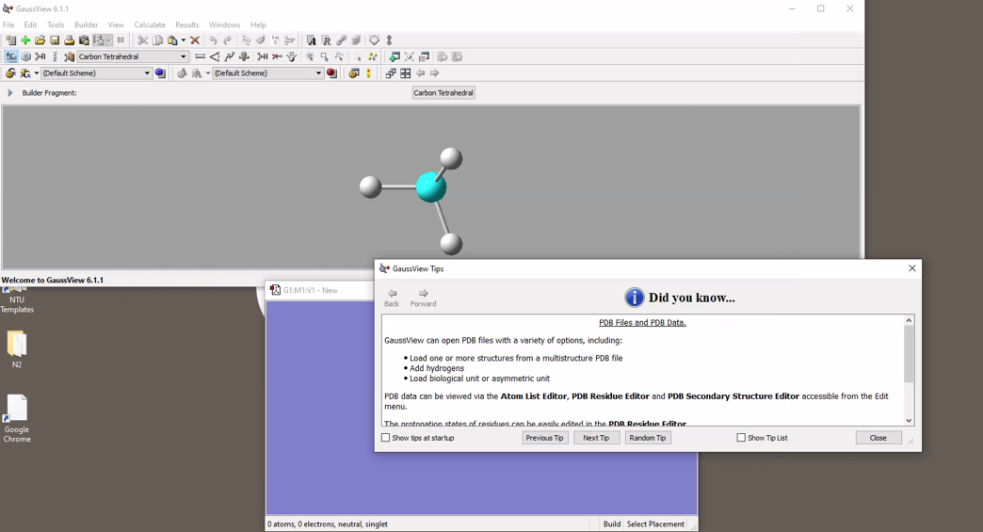

Now we need a structure:

Open the following paper: https://doi.org/10.1016/j.ejmech.2020.112377. This paper gives the Protein Databank (PDB) code for the PD-L1 protein complexed with BMS-8. Once you’ve found identified the code, in a web browser, go to https://www.rcsb.org and search for the protein.

From the “Structure Summary” window, select “Ligand Interaction”

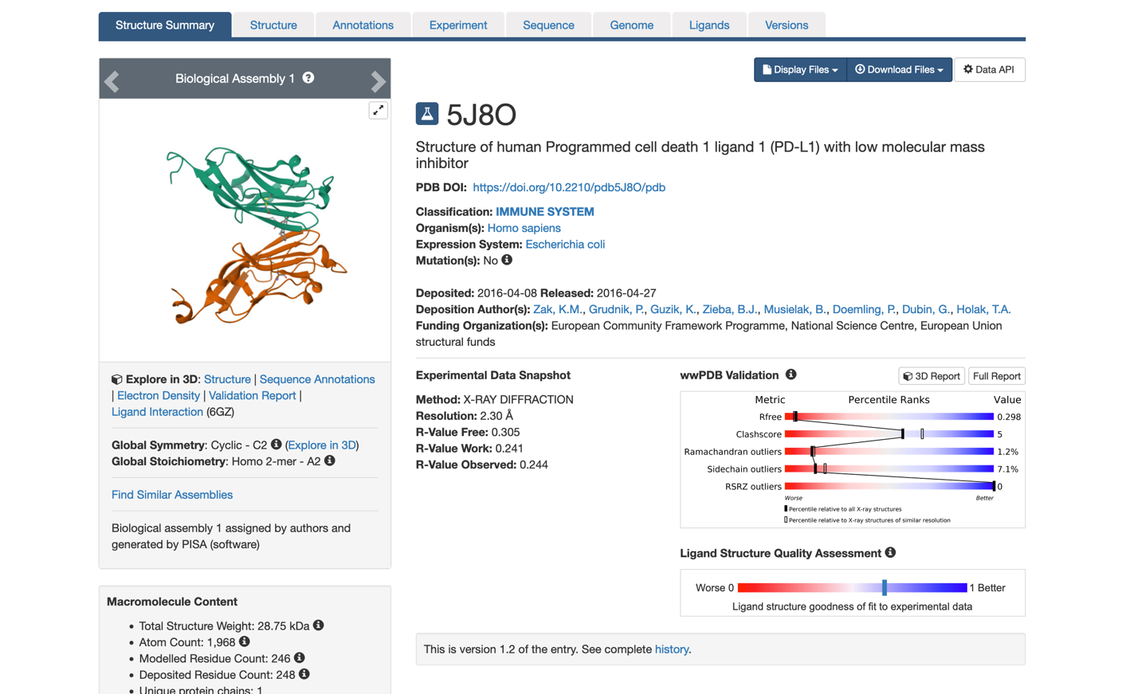

From here, you can identify which residues bind with the BMS-8 molecule.

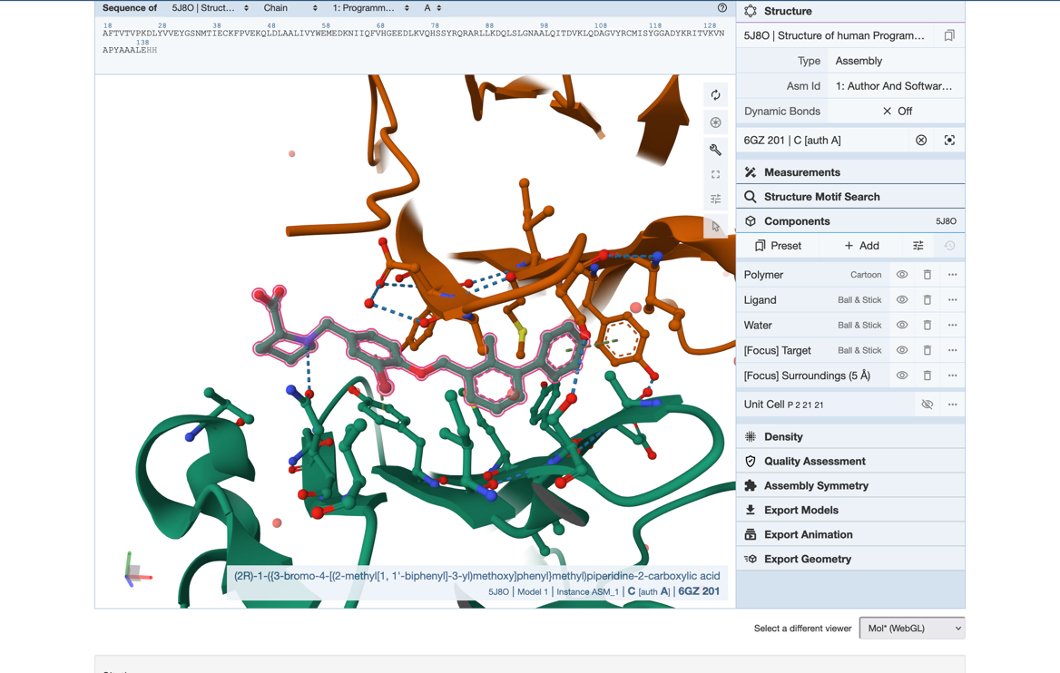

Mouseover the dashed bonds between the BMS-8 molecule and protein residues. Note the number and type of interactions.

Now we can download the structure file. Return to the “Structure Summary” page and download the PDB file:

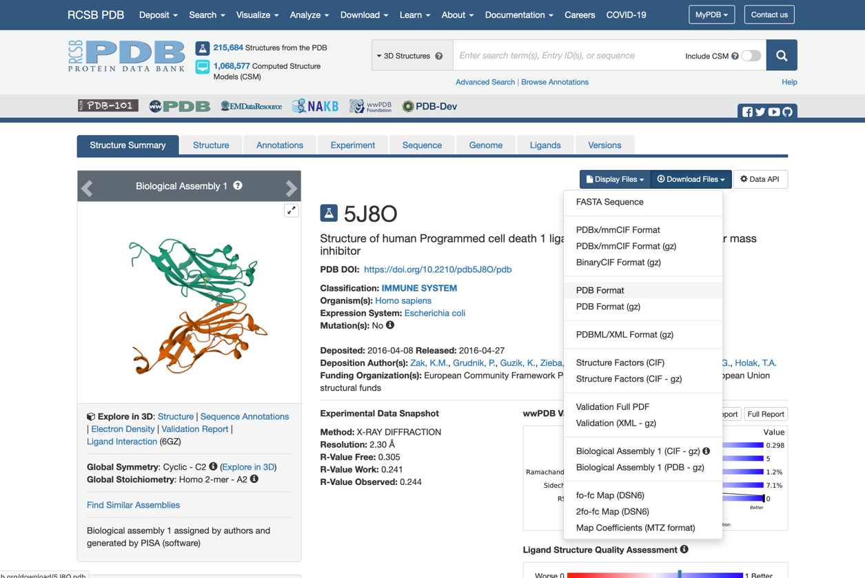

Open the downloaded file in GaussView and select “Yes” when asked to add hydrogens to structure. A new molecule window will open with the PDB file displayed. You will see the BMS-8 molecule in ball-and-stick view and the protein in wireframe view:

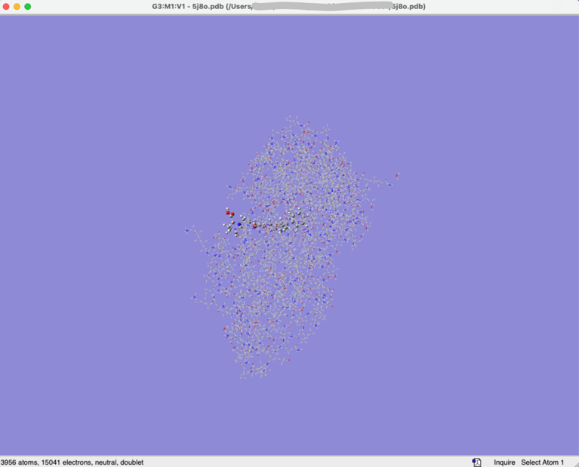

From the “Tools” menu, select “PDB Residues…”. In the editor that opens, double-click the “Display” heading to select all rows and in Row , change “Show” to “Hide” to hide your entire structure. Clicking anywhere in the editor will deselect the residues (yellow highlight will disappear). Now select only the BMS-8 molecule and the residues that directly interact with the BMS-8 molecule. (Hint: use the RSCB PDB and/or BMS_8 Ref 1 to identify the relevant residues). https://doi.org/10.1016/j.ejmech.2020.112377

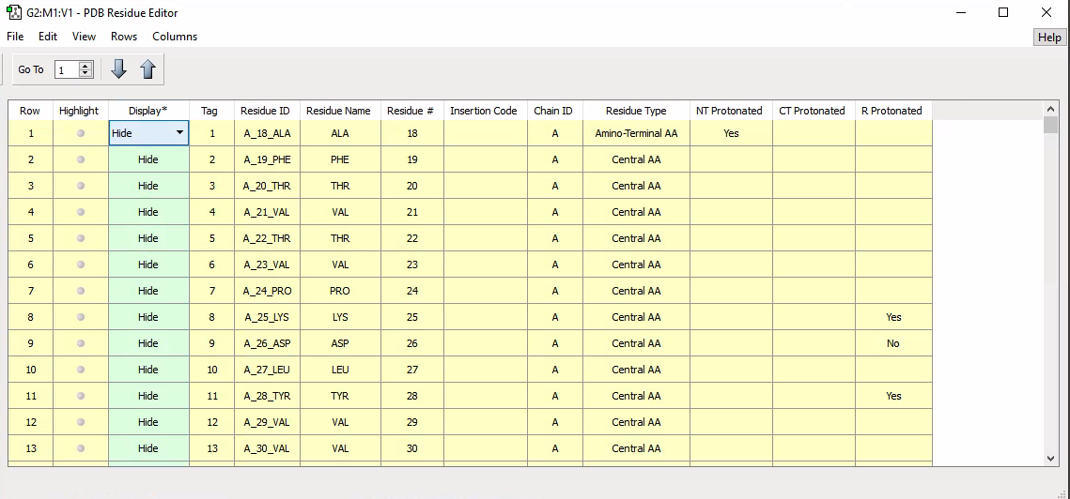

Once you’ve “Show”n the BMS-8 molecule and all the residues it interacts with, Select any residue that is “Show”n (Hint: you can highlight any column by double-clicking the title and use the up/down arrows on the screen to sort by column) and from the “Rows” menu, select “Generally-Select Atoms of Selected Rows”.

From the edit menu of the main GaussView window, select Copy and then Paste. The molecule plus any residues you have selected will be pasted in a new molecule window. Check the residues – each residue should have a bond going into empty space. This is where the particular residue joins the rest of the protein. Use the Builder (View Builder) to replace all dangling bonds with Hydrogen atoms.

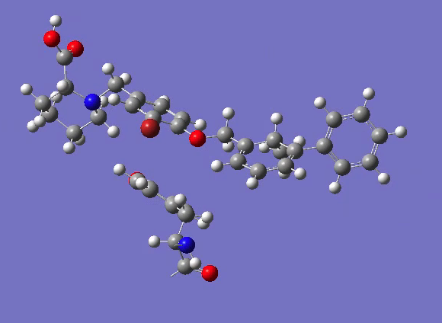

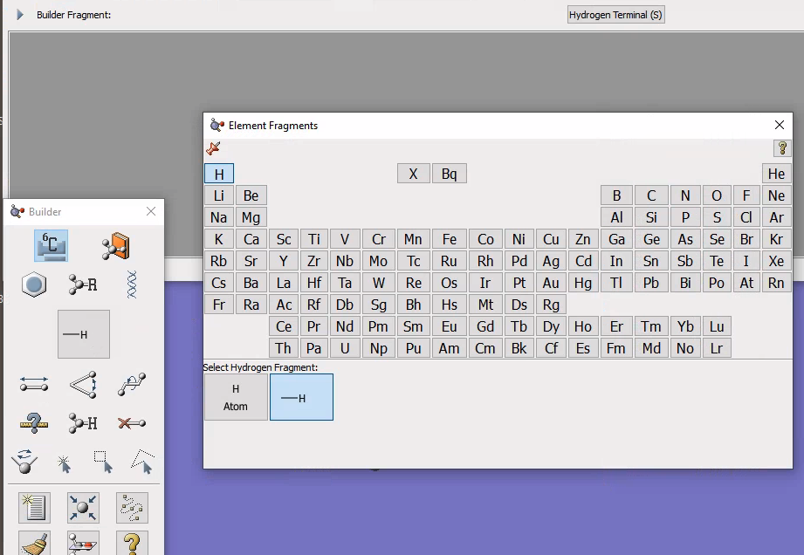

There’s one more edit we need to make. When GaussView automatically adds hydrogen atoms, it guesses the hydrogen positions based on the positions of the heavy (carbon, nitrogen, oxygen etc.) atoms. In this protein structure, the BMS-8 molecule is slightly wonky, and so GaussView guesses an extra hydrogen atom that we need to remove. You can see that what should be a benzene ring with a methyl group, has one extra hydrogen and broken the aromaticity:

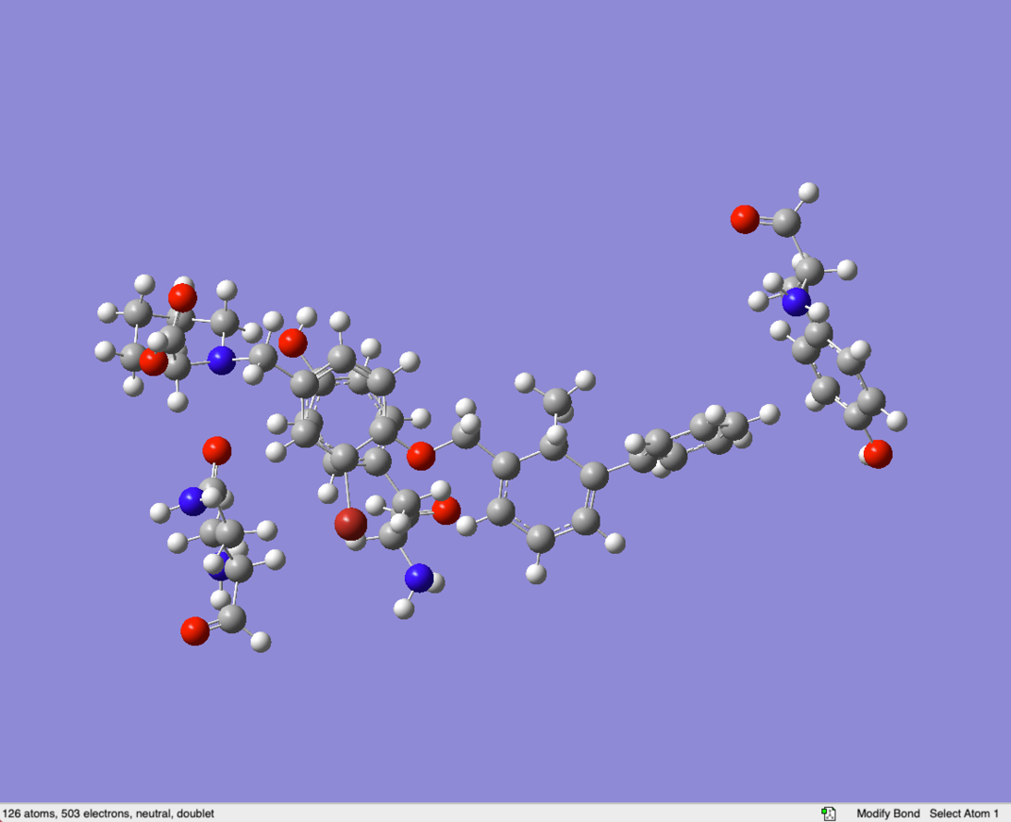

Use the delete, bond and angle tools to correct the geometry around the phenyl group:

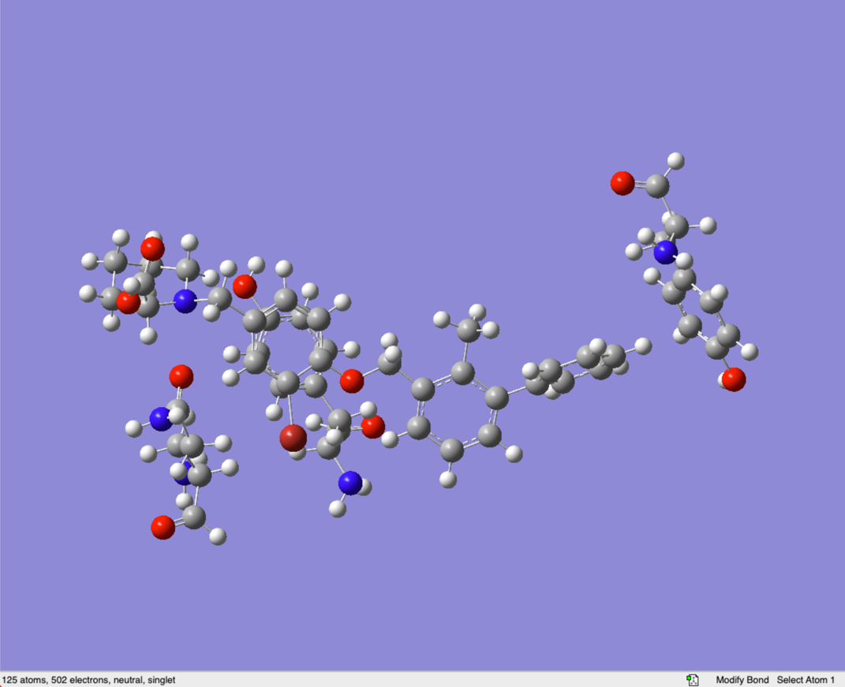

Now we’re ready to start some calculations. First, save the file (File Save…) , the extension should be “gjf” (which stands for Gaussian Input File, but .gif was already taken…)

Our first aim is to compute the interaction energy of BMS-8 with each of the individual residues. We will use the semi-empirical method, PM6 for all calculations. To run a calculation, select Calculate Gaussian Calculation Setup:

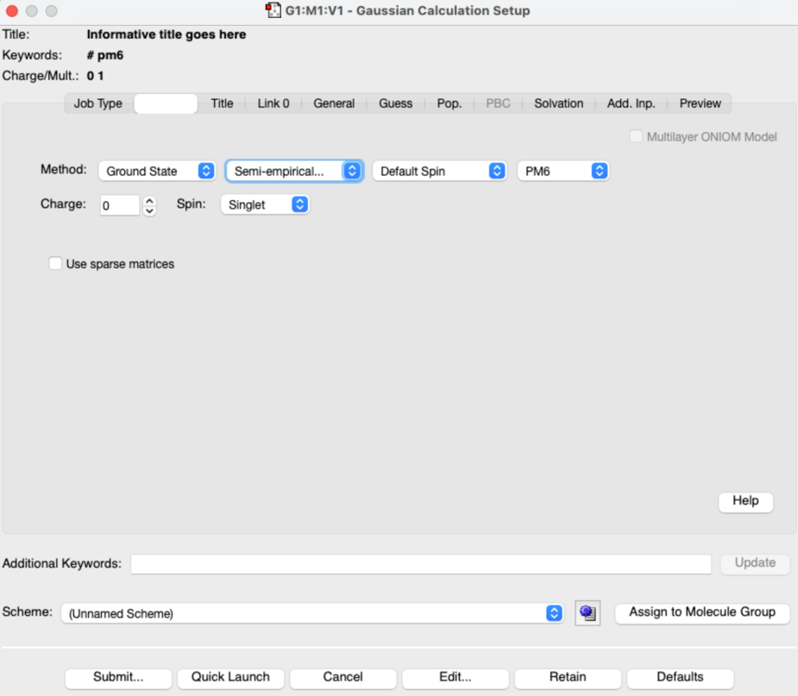

In the Title tab, give your job an informative title, and in the Method tab , select Semi-empirical, then PM6. Run the job using the “Submit” button. You’ll get a popup confirmation window. Click “Yes”.
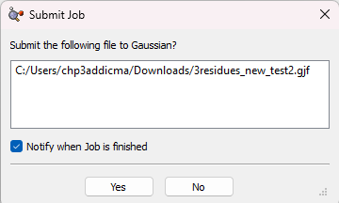

In a few minutes the calculation will complete and you will get a popup window:
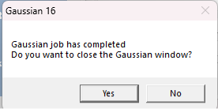

Click “Yes” to close the calculation window. Another window will appear:

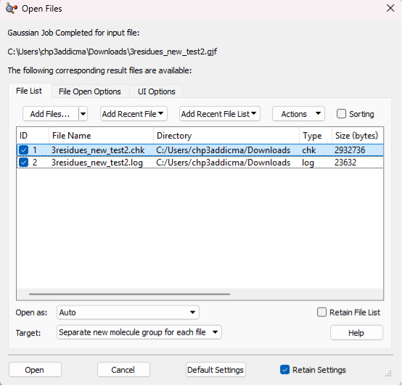
Make sure both the “log” and “chk” files are checked and then click “Open”. In the new GaussView window that appears, you can now access the results from the Results menu. In the first instance, select “Summary”. Copy the Electronic Energy into a spreadsheet. Keep Electronic energies in Hartree and only convert binding energies to kJ/mol (Conversion factor = 2625.5).

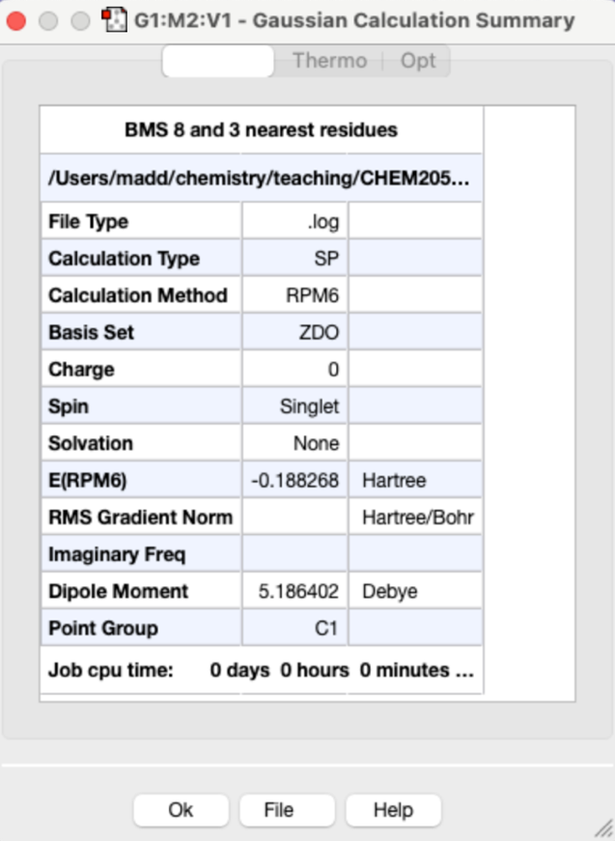

Remembering the basic formula for binding energy:

BE = E_{AB} – [E_{A} + E_{B}]

You will need to complete several energy calculations in order to determine the binding energy of:

- BMS-8 with each individual residue (E_{AB} – [E_{A} + E_{B}], E_{AC} – [E_{A} + E_{C}], …)
- BMS-8 with all residues E_{ABCD} – [E_{A} + E_{B} + E_{C} + E_{D}]
- BMS-8 with all residues E_{ABCD} – [E_{A} + E_{BCD}]

The PDB, where you previously identified the interactions, will also tell you the type of interaction (e.g. pi-stacking, hydrogen bonding).

Questions:
- What are the energies of pi-stacking interactions and hydrogen bonds?
- Are the energies you compute consistent with typical non-bonded interaction energies?
- Do the interactions of BMS-8 with each residue sum to the binding energy of BMS-8 with all residues? Why / why not? (Hint: consider the difference between Binding Energies #2 and #3 above)
- Which parts of the BMS-8 molecule are most important for binding with the protein? Which parts of the molecule do you think you can change?

Part 2: Derivatives of BMS-8

BMS-8 is not a regular molecule name (like “caffeine”, “ethanol” or “2,3-dimethylpyrazine). It stands for Bristol-Myers Squibb (name of the company), and the number “8” means simply the eighth molecule in their list. We’re going to do some stuff based on that list.

The patent including BMS-8 can be downloaded here: WO2015034820A1.

It’s a long document, but within the pdf file, there are 4 relevant sections, “Example 1” (page 43), “Examples” (page 51), “Structures” (page 84) and “IC50 values” (page 168).

Taking a quick look first at “Structures” (starts on Page 84 of the pdf), you can see that the patent covers a long list of related compounds – you should be able to see similarity in all the chemdraw structures listed. These related structures are analogs of the core structure.

Question:
- Identify the parts of the molecule that change or stay the same and produce a coloured ChemDraw sketch of BMS-8, with each colour representing a part of the molecule. You should end up with the BMS-8 molecule with three colours.
- For the parts of the BMS-8 molecule that are changeable, make a table of possible switches. No need to identify all of them (there are lots in the patent, and many more are possible). Identify at least 5 possible switches for each changeable part.

Now that you’ve identified the parts of the BMS-8 molecule that are fixed and changeable, we can work out how much it would cost to synthesise derivatives of BMS-8.
Our motivation is, “Our biology colleagues require 20mg of each BMS-x analog in order to test their biological activity. How much will the required reagents cost?” To simplify things, we will assume that we are charged only for the reagents we use, even if we have to buy a larger packet.

Having noted that the analogs are structurally very similar (which is what we mean by analog), a sensible strategy is to make a large amount of the intermediates, which can then be used in several small-scale reactions to make 20mg of many target compounds. This is exactly what the chemists at Bristol-Myers Squibb did [Example 1, page 43], synthesising 2g of Intermediate 1A (and 1B) and then using 20mg of Intermediate 1B for many syntheses.

“Examples 6, 7, 9-15, 17, 18, 21, 24-26, 32, 36, 37, 46-48, 69, 84, 103, 105, 111, 163-190, 195, 196, 233-244 and 246-284 in the table were prepared from Intermediate 1B, 2,6-dimethoxy-4-((2-methylbiphenyl-3-yl)methoxy)benzaldehyde, and an appropriate amine according to the general synthetic process described for Example 1.”

With this method, is a spreadsheet that we’ve started for you. Firstly, we’ll use two tabs of the spreadsheet, the “Synthesis” tab, which in turn refers to the “CAS_E-Catalogue” tab.

Most of the formulae used are fairly standard Excel formulae, the key formula that might be new is:

=INDEX('CAS_E-Catalogue'!$C:$F,MATCH(D16,'CAS_E-Catalogue'!$C:$C,0),3)/INDEX('CAS_E-Catalogue'!$C:$F,MATCH(D16,'CAS_E-Catalogue'!$C:$C,0),4)

What this formula does, is MATCHes the CAS number in cell D16 in the ‘CAS_E-Catalogue’ (columns C to F) and then takes the value in the third column (column E, which is the price in GBP) and then makes the same MATCH again to get the value in the fourth column (column F, the packet size). This way, we get a price per gram.

The spreadsheet you’ve been given has already calculated the cost for the example compounds above that are synthesised directly from Intermediate 1B. However, reading from “Examples” (pages 51 and 52), several more analogs can be made in the same manner by changing Intermediate 1B. We’ll work out the cost of these analogs.

“Examples 8, 22, 29, 67 and 104 were prepared according to the general procedure described in Example 1 except 3-bromo-4-hydroxybenzaldehyde was used instead of 4-10 hydroxy-2,6-dimethoxybenzaldehyde and an appropriate amine was used for reductive amination instead of piperidine-2-carboxylic acid.”

This paragraph describes:
- The synthesis of Intermediate 1B is changed: 3-bromo-4-hydroxybenzaldehyde replaces 4-10 hydroxy-2,6-dimethoxybenzaldehyde
- In the next step (final step, reductive amination), “an appropriate amine” was used instead of piperidine-2-carboxylic acid.

So we need to:
- Insert 10 more rows in the spreadsheet below the costing of Intermediate 1B.
- Copy the costing of Intermediate 1B into those rows
- Write an informative heading, “Second intermediate for examples 8, 22, 29, 67 and 104”
- All the reagents are the same except the aldehyde, so write the name of the new aldehyde into the “Reagent Name” column.
- Now we need to find the CAS number. The easiest way to do this is to use SciFinder:
- Once you’ve registered for SciFinder, go to SciFinder and in the “Substances” tab, type in “3-bromo-4-hydroxybenzaldehyde” and search
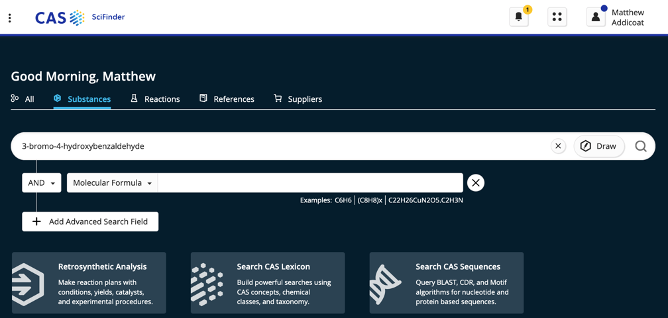

You should get only one result, and the CAS number is listed at the top. Copy and paste it into the “CAS No” column. The aldehyde is already listed in the “CAS_E-Catalogue”, so the price should be found and calculated automatically. Next copy-paste the molecular weight into the MW column.

- Calculate the molecular weight of the new Intermediate 1B and enter it in the appropriate cell.
- Now that we’ve costed the intermediate for Examples 8, 22, 29, 67 and 104; we need to identify “the appropriate amine” for the final step of the synthesis.
To work out how to do this, we’ll use Example 1 from the patent:
Example 1 is synthesised from Intermediate 1B and (S)-piperidine-2-carboxylic acid. The atoms that don’t end up in the final product are coloured in red.
Looking at our product, our “appropriate amine” is therefore everything to the right side of the nitrogen, including the nitrogen and then adding the right number of hydrogens to the nitrogen atom.
Look at the structures of the final analog compounds [patent “Structures” (page 84)] and work out the “appropriate amines” for each of the five example compounds above (Examples 8, 22, 29, 67 and 104) and find their CAS numbers.
The easiest way to find the CAS numbers is SciFinder, but this time, seeing as we might not know the chemical name, we want to draw the reagent:
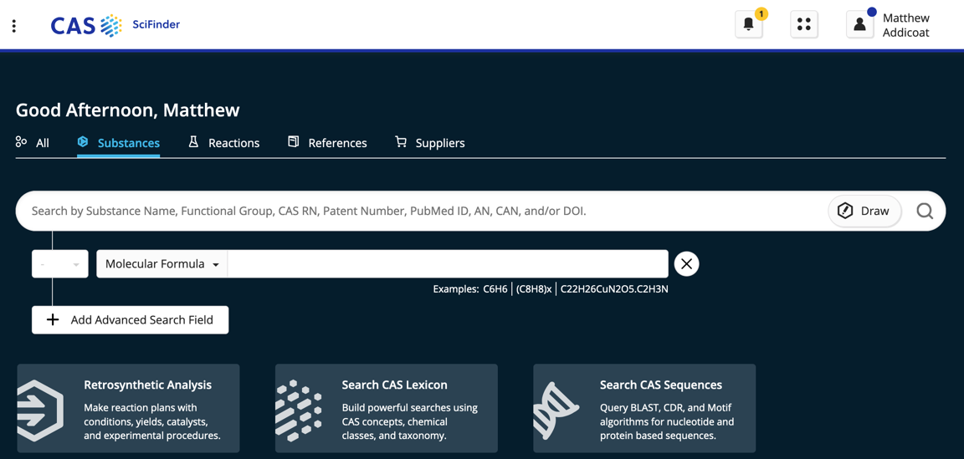
Clicking on the “Draw” button, takes us to a ChemDraw-like window:
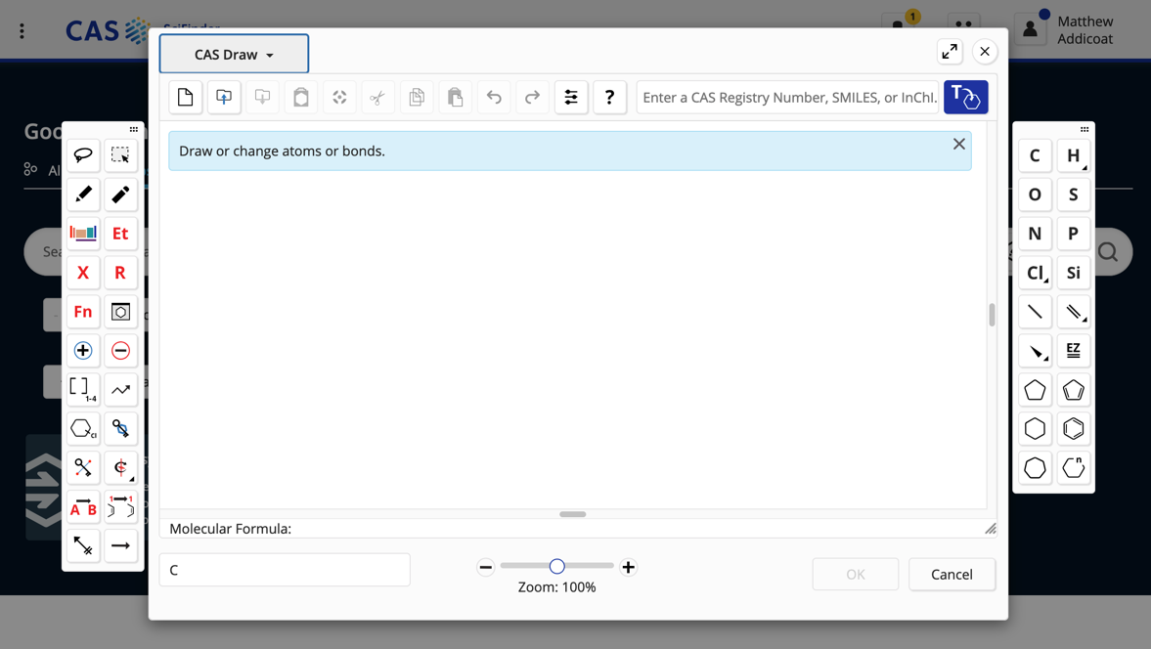
Draw the appropriate amine, here I’ve drawn the amine for BMS-8:
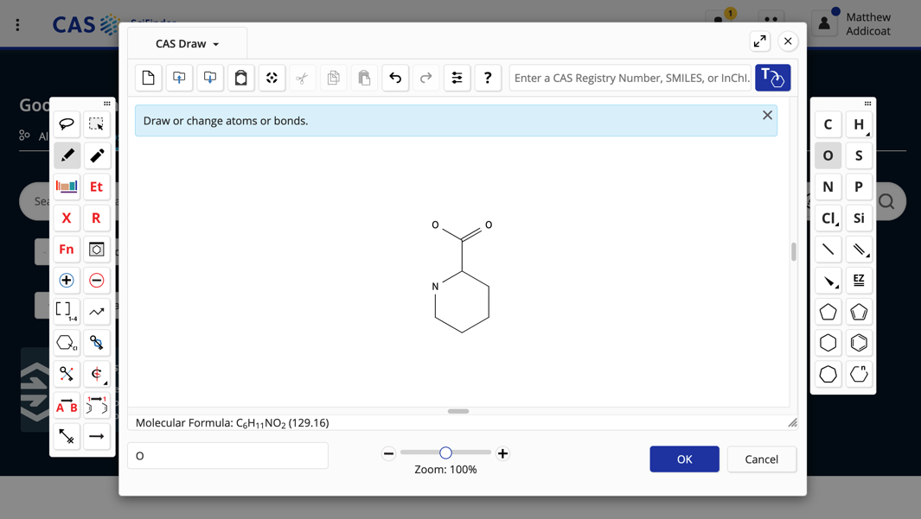
Note that you don’t need to fill in all the hydrogen atoms – the builder will assume any valences are filled with the right number of H atoms.
Click “OK”, then “Search” (the magnifying glass). You’ll get lots of results:
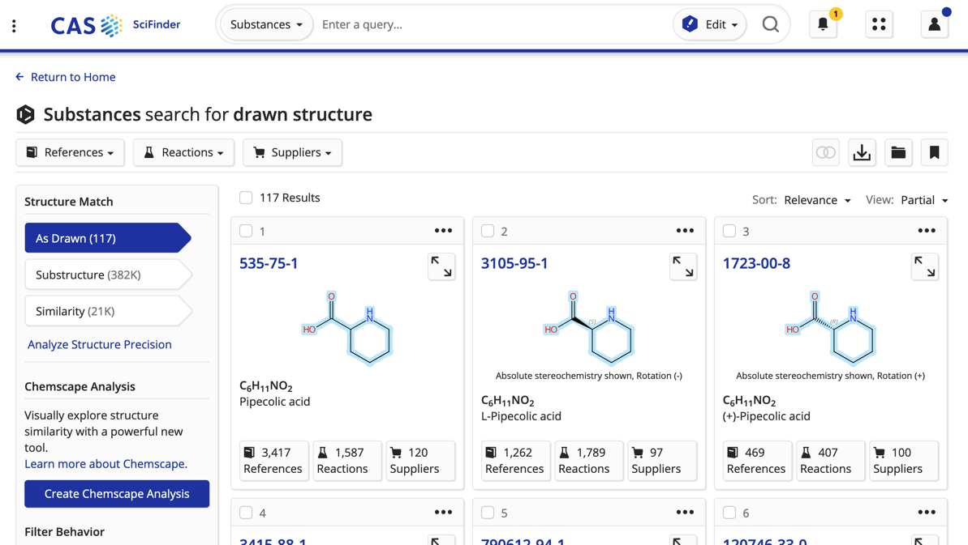
In this case, it’s the first result we need, note the CAS Number, and click through to find the molecular weight.
Note that if you needed to, you can also find suppliers and costs through the results:
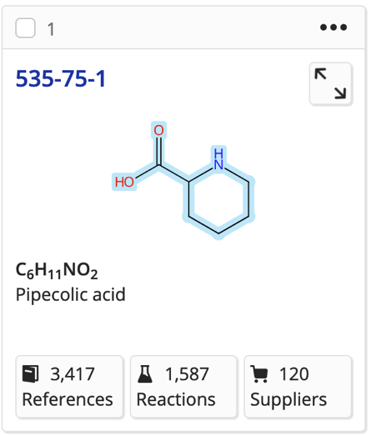
Most of the amines we need should already be in the “CAS_E-Catalogue”
- Now we have all the information we need to calculate the cost of the synthesis. Following the patent “Example 1”, we’ll assume that:
  - We start with 20mg of our (modified) Intermediate 1B (and use the same number of moles of our amine)
  - That our yield of this reaction is the same as the BMS chemists’ yield (calculated in the spreadsheet to be 77.35%)
In the spreadsheet, below “Example 284” add in a new row, you can fill in the Example number, reagent name, CAS Number and MW. The formulae for “mass”, “Price (GBP/g)” “assumed mass” and “cost/g synth” can be copied from the cells above.
To calculate the number of moles, “n” divide the “Starting Mass of Intermediate” by the MW of the modified Intermediate 1B. All the other cells will update.
- Repeat Step 9 for the other amines using this intermediate (Examples 22, 29, 67 and 104).
- To compute the total cost of the synthesis reagents, make sure the SUM formula in cell Q3 covers all the synthesised analogs.
- Working in groups, repeat Steps 1-10 to extend the spreadsheet to include all the analogs that can be made using the procedure of Example 1 [patent, “Examples” (page 51 and 52]].

Part 2b: Linking the 3D structure and 2D ChemDraw

GaussView allows us to colour / highlight our atoms in the same way as we did in ChemDraw. Use the Select tool in the Builder to select atoms from your BMS-8 molecule and add them to Atom Groups (Tools Atom Groups…)

Here, I’ve added a fourth atom group to hold the three protein residues.

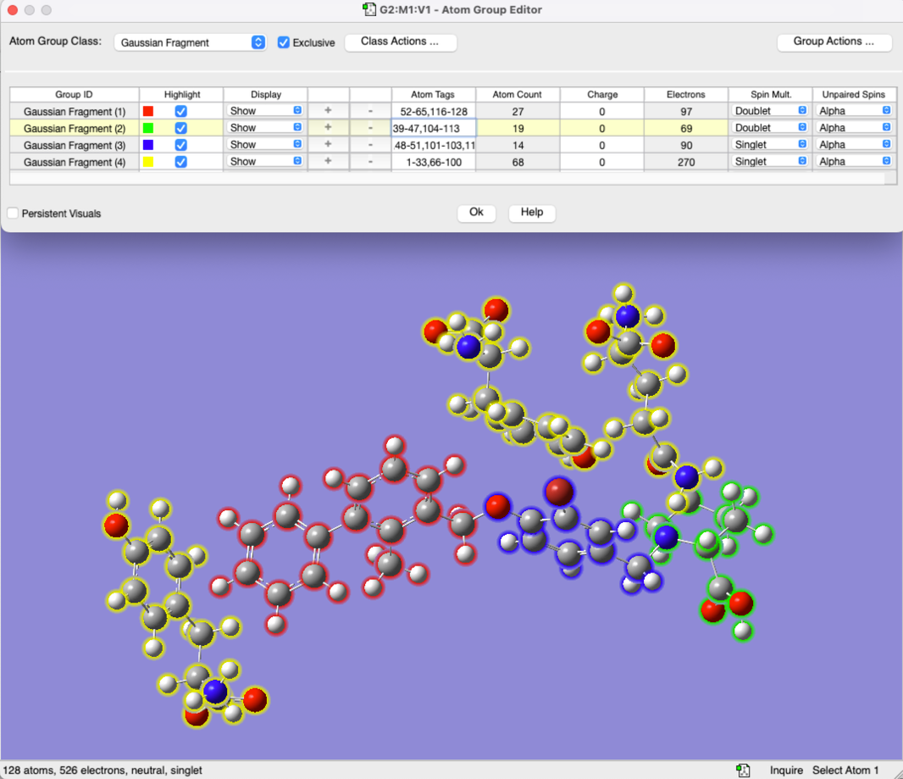

Questions:
- Relate the parts of the BMS-8 molecule that you’ve coloured / highlighted to the interactions (pi-stacking and hydrogen bonding) with the individual protein residues.
- When you make an analog of the BMS-8 molecule, which of these molecule-protein interactions are you changing?

Part 2c: Solvents

In the analysis above, we did not consider solvent usage, nor disposal. Jump now to the “Solvents” tab on the spreadsheet. The information here is mostly copied from the patent “Example 1” (page 43). By far the biggest use of solvent is in the purification of the crude product:

“The crude material was purified via preparative LC/MS with the following
conditions: Column: Waters XBridge C18, 19 x 200 mm, 5-μm particles; Mobile Phase A: water with 20-mM ammonium acetate; Mobile Phase B: 95:5 acetonitrile:water with 20-mM ammonium acetate; Gradient: 25-65% B over 20 minutes, then a 5-minute hold at 100% B; Flow: 20 mL/min.”

Assuming the same solvent usage per synthesis, calculate the volume and cost of the solvent used. CAS Numbers are already entered in the “Solvents” tab. Remember to include the cost of solvent disposal, which is £6.50 per 10L of non-halogenated solvent and £9.50 per 10L of halogenated solvent.

Part 3: Calculated Binding Energies

The one tab we haven’t done anything with so far is “Assay IC50 values”. This data is taken from the patent [“IC50 values”, page 168]. In the patent, most exact values are not given, just a range, denoted “A”, “B”, and “C” for low – high IC₅₀ values.

We would like to see if there is a correlation between the IC₅₀ value and the computed binding energy. Using the procedure and your input files from Part 1, choose one analog with each of “A”, “B” and “C” IC₅₀ values, alter BMS-8 structure to that of your chosen analog and calculate the binding energies in the same way as Part 1. You should be able to comment on the parts of the molecule that you have changed and the intermolecular interactions that you’ve thereby altered.

The structure that we have includes three amino acid residues, that were extracted from the x-ray crystal structure of BMS-8@protein (BMS-8 in the protein). In theory, if we were to want “good” binding energies for our new BMS-n analogs, we would allow the entire protein structure to relax and optimize around the new analog. In reality, this is incredibly expensive, and so we will make two approximations:
- We will retain only the three amino acid residues we already extracted
- We will fix the positions of these residues in the same position as they were for BMS-8, and allow only the molecule to optimise its position.

To do this, open the Atom Groups window (Tools → Atom Groups) and in the Atom Group Class dropdown menu (top left), select “Freeze”. Then freeze (Freeze (Yes)) all the atoms in the three amino acid residues:
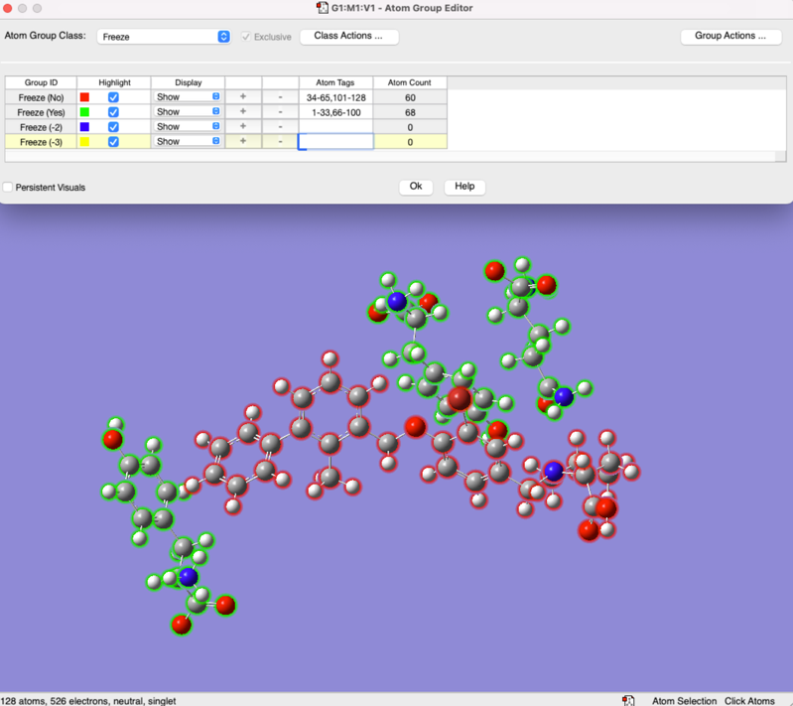

Click “OK” and now you can do the calculation (Calculate → Gaussian Calculation Setup). In the “Job Type” tab, choose “Optimization” and make sure PM6 is still selected as the method. Save the file with a new name (don’t overwrite your BMS-8 calculations!) and submit. This calculation will take 5-10 minutes.

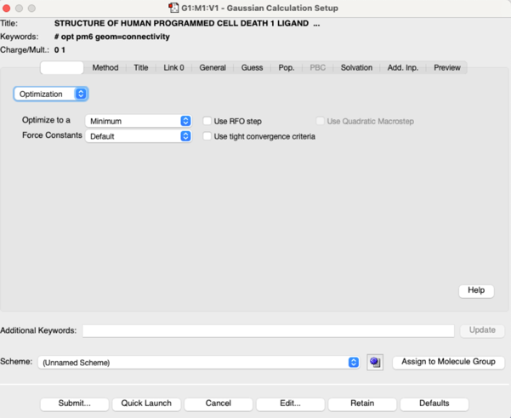

Once you’ve calculated the new molecule position in the protein fragments, you’ll need to calculate single point the single point (“Energy”) of the molecule to calculate your binding energies.

Reminder of formula for overall interaction / binding energy:

BMS-n with all residues E_{ABCD} – [E_{A} + E_{BCD}]
Scroll back to Part 1 for other binding energy definitions.

Enter your computed values on the class spreadsheet.

